FOR IMMEDIATE RELEASE Nov. 18, 2018

The Missing Link: Groundbreaking New Product Bridges the Gap
Between Tenkara & Traditional Western-Style Fly Fishing
Kickstarter Campaign Launching on Cyber Monday

Providence, Rhode Island, Nov. 18, 2018 — After two years of development and testing, award-winning product designer and fisherman Paul Osimo is launching a Kickstarter campaign to fund a groundbreaking new product: the lo-fli fli fishing system. The 30-day campaign is scheduled to launch on Cyber Monday, Nov. 26, and will run through Dec. 26. Once live, the campaign can be accessed at bit.ly/lo-fli. Links also can be found at lo-fli.com and on lo-fli social media profiles.

The lo-fli system provides anglers with the unique opportunity to both hone their fly casting techniques and to fish with an unparalleled alternative to traditional Western-style fly fishing methods. Its abbreviated length permits the fisherman to fish in places where traditional equipment does not allow, and it gives him the ability to practice casting skills in everyday indoor and outdoor locations. The system has no moving parts and no buzzing drag. The fight begins and ends at the angler’s fingertips. Its design allows for accurate technique in even small or cramped areas, making it possible to reach fish hideaways and other tight spots.

Care has been taken to ensure a high-quality product. lo-fli has partnered with well-known rod manufacturer Batson Enterprises to develop lo-fli’s flagship rod. Another top-of-the-line U.S. manufacturer is producing the patent-pending cast brass action spool, which is the key to lo-fli’s iconic look.

For those interested in gifting this innovative fly fishing setup to their favorite angler during the 2018 holiday season, lo-fli, Inc. is offering a downloadable preorder “certificate of pledge” for those who pledge to back the Kickstarter campaign before Christmas, with all pledge packages planned to ship in time for spring.

CONTACT:
Paul Osimo 508-367-9224
Katy Dika 401-451-6137
info@lo-fli.com
www.lo-fli.com

PRESS KIT:
https://www.lo-fli.com/press-kit

SOCIAL MEDIA:
instagram: @lo_fli
twitter: @Totally_Unreel
facebook: @lo-fliunreelflyfishing

KICKSTARTER:
http://bit.ly/lo-fli
###
About lo-fli:

The lo-fli fly fishing system provides the angler with the unique opportunity to both hone their fly casting technique and to fish with an unparalleled alternative to traditional fly fishing methods. The fight begins and ends at your fingertips. Every head shake, every run will be at the whim of your finger pressure and skill. No moving parts, no buzzing drag to drown out the sound of a native brookie attempting an escape over a hopelessly shallow riffle. lo-fli offers a one-of-a-kind skill-honing and fly fishing system.

About Paul Osimo:

lo-fli system designer Paul Osimo is a professional product designer with over 15 years of industrial design experience, a BA in Industrial Design from the prestigious Rhode Island School of Design and an obsessive fisherman. He worked as co-captain and mate beside world famous sport fisherman and author Captain Alan Anderson. Paul experimented and developed innovative fishing solutions with Alan for many years. Paul has also designed fishing products for fishing companies such as Mystery Tackle Box and has developed dive toys and other hydrodynamic aquatic toys, including a line of inflatable Paipos (primitive Hawaiian body boards) that earned him the esteemed International Design Award (IDA) in 2014.

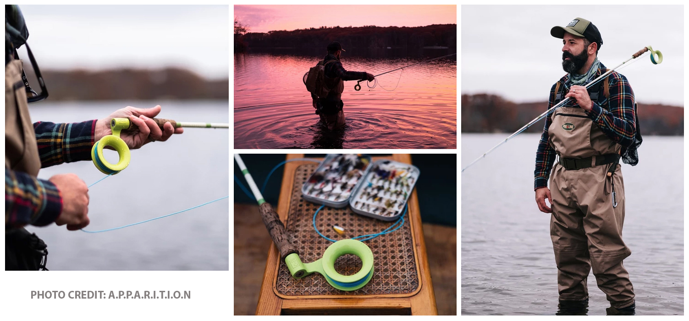
High-res images are available in our online press kit: https://www.lo-fli.com/press-kit

